University of Central Missouri

Department of Computer Science & Cybersecurity

CS5760 Natural Language Processing

Fall 2026

Homework 2.

Student name: Srinivas Reddy Pittu

Submission Requirements:
- Once finished your assignment push your source code to your repo (GitHub) and explain the work through the ReadMe file properly. Make sure you add your student info in the ReadMe file.
- Submit your GitHub link on the Bright Space.
- Comment your code appropriately IMPORTANT.
- Any submission after provided deadline is considered as a late submission.

Part I. Writing Calculation
Q1. Worked Example Document Classification (based on slide: Test document “predictable no fun”)
Using the smoothed likelihoods and priors from Q2, compute the probability scores for the document “predictable no fun” under both the positive and negative classes.

Tasks:
- Show each step of the multiplication.
- Which class should the system assign to this document?
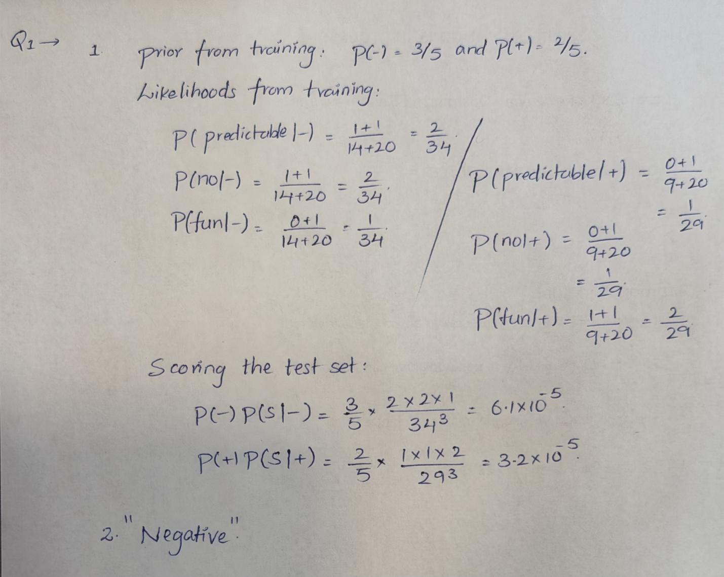
Q2. Harms of Classification (based on slide: Avoiding Harms in Classification)

Tasks:
- Define representational harm and explain how the Kiritchenko & Mohammad (2018) study demonstrates this type of harm.
Ans: Representational harm occurs when a system demeans a social group or repeats negative stereotypes about that group. The lecture describes a study by Kiritchenko and Mohammad (2018) that examined 200 sentiment analysis systems. The systems received sentence pairs that differed only in the names, such as “I talked to Shaniqua yesterday” and “I talked to Stephanie yesterday.” Sentences with African American names received lower sentiment scores and more negative emotion than sentences with European American names. Because the other words were unchanged, this shows unequal treatment based on the names. Such results can reinforce stereotypes and affect how people are represented by NLP tools.
- What is one risk of censorship in toxicity classification systems (based on Dixon et al. 2018, Oliva et al. 2021)?
Ans: One risk is that harmless speech about minority identities may be flagged as toxic and removed or made less visible. The lecture cites Dixon et al. (2018) and Oliva et al. (2021) when discussing gay people. A non-toxic sentence that includes the word “gay” could be incorrectly treated as abusive. This can censor people discussing their identity and discourage them from using identity terms online.
- Give one reason why classifiers may perform worse on African American English or Indian English, even though they are varieties of English.
Ans: The training data may not include enough examples of African American English or Indian English. A classifier trained mostly on other English varieties may learn unfamiliar vocabulary, grammar, or spelling patterns poorly. For example, a language identification model may wrongly decide that an English post is not English. More representative training data is needed; these varieties are valid forms of English.

Q3. Bigram Probabilities and the Zero-Probability Problem
You are given the following bigram counts from a small training corpus:
Previous word | Next words (with counts)
<s> | I: 2 , deep: 1
I | love: 2
love | NLP: 1 , deep: 1
deep | learning: 2
learning | </s>: 1 , is: 1
NLP | </s>: 1
is | fun: 1
fun | </s>: 1
ate | lunch: 6 , dinner: 3 , a: 2 , the: 1

Tasks:
- Bigram Sentence Probabilities
Using maximum likelihood estimation (MLE):
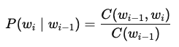
  - Compute the probability of sentence S1: <s> I love NLP </s>.
  - Compute the probability of sentence S2: <s> I love deep learning </s>.
  - Which sentence is more probable under the bigram model?
- Zero-Probability Problem
Using the same table, compute:
  - P(noodle∣ate) with MLE.
  - Explain why this probability creates problems when computing sentence probabilities or perplexity.
  - Apply Laplace smoothing (Add-1) to recompute P(noodle∣ate). Assume the vocabulary size is 10 and total count after “ate” is 12.
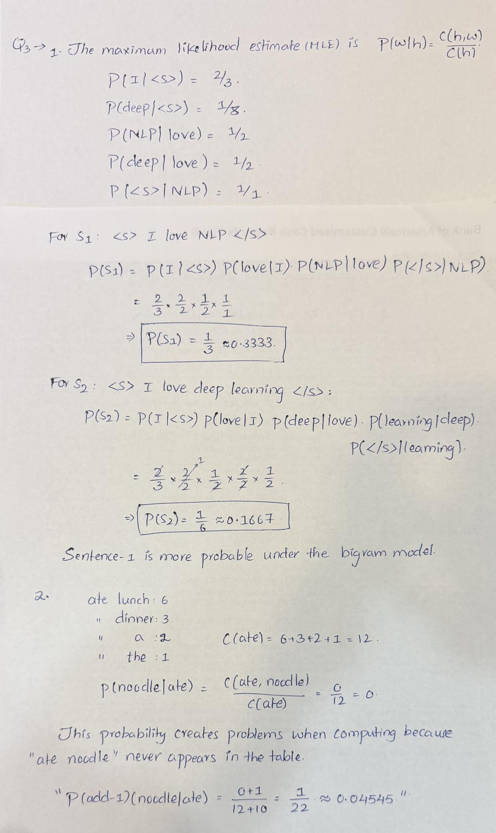

Q4. Backoff Model (based on “Activity: <s> I like cats … You like dogs” slide)
Training corpus:
<s> I like cats </s>
<s> I like dogs </s>
<s> You like cats </s>
Counts:
- I like = 2
- You like = 1
- like cats = 2
- like dogs = 1
- cats </s> = 2
- dogs </s> = 1

Tasks:
- Compute P(cats∣I,like).
- Compute P(dogs∣You,like) using trigram → bigram backoff.
- Explain why backoff is necessary in this example.
Sol:
P(cats | I, like) = count(I like cats)/count(I like) = 1/2 = 0.5
P(dogs | like) = count(like dogs)/(count(like cats) + count(like dogs)) = 1/3 ≈ 0.333333
Backoff is necessary because the longer context has too little training data. The corpus never contains “You like dogs,” but it does contain “like dogs.” Using the shorter context gives a useful estimate instead of forcing this unseen trigram to have probability zero.

Q5: Evaluation Metrics from a Multi-Class Confusion Matrix
The system classified 90 animals into Cat, Dog, or Rabbit. The results are shown below:
System \ Gold | Cat | Dog | Rabbit
Cat | 5 | 10 | 5
Dog | 15 | 20 | 10
Rabbit | 0 | 15 | 10

Tasks:
- Per-Class Metrics
  - Compute precision and recall for each class (Cat, Dog, Rabbit).
- Macro vs. Micro Averaging
  - Compute the macro-averaged precision and recall.
  - Compute the micro-averaged precision and recall.
  - Briefly explain the difference in interpretation between macro and micro averaging.
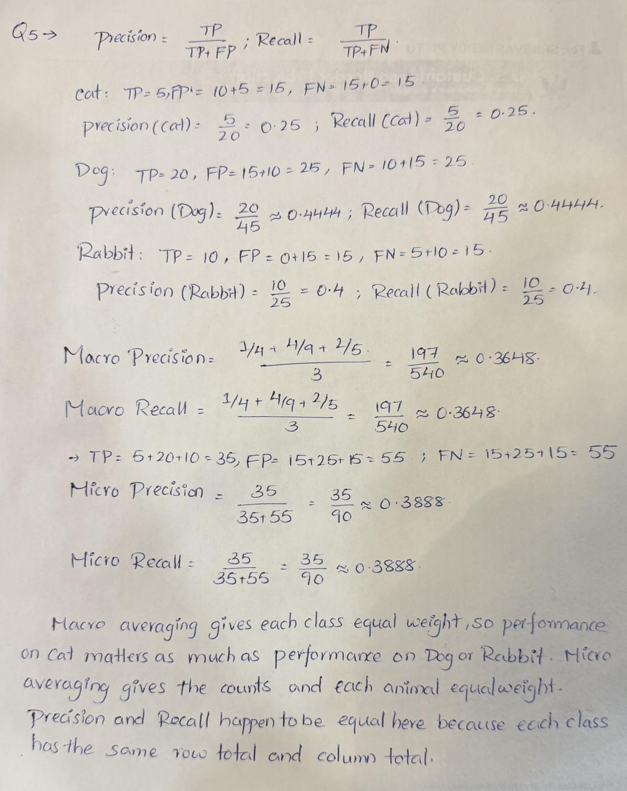
- Programming Implementation
Write Python code that:
  - Accepts the confusion matrix above as input.
  - Computes per-class precision and recall.
  - Computes macro-averaged and micro-averaged precision and recall.
  - Prints all results clearly.
def calculate_metrics(matrix, labels):
"""Rows are system predictions; columns are gold labels."""
n = len(labels)
if n == 0 or len(matrix) != n or any(len(r) != n for r in matrix):
raise ValueError("Provide a square matrix and one label per class.")
if any(not isinstance(x, int) or x < 0 for r in matrix for x in r):
raise ValueError("Counts must be nonnegative integers.")

results = []
total_tp = total_fp = total_fn = 0
for i, label in enumerate(labels):
tp = matrix[i][i]
fp = sum(matrix[i]) - tp # Other gold labels in this row.
fn = sum(row[i] for row in matrix) - tp # Other predictions.
precision = tp / (tp + fp) if tp + fp else 0.0
recall = tp / (tp + fn) if tp + fn else 0.0
results.append((label, tp, fp, fn, precision, recall))
total_tp += tp
total_fp += fp
total_fn += fn

# Macro averages give each class equal weight.
macro_p = sum(r[4] for r in results) / n
macro_r = sum(r[5] for r in results) / n
# Micro averages pool the counts before dividing.
pred_total = total_tp + total_fp
gold_total = total_tp + total_fn
micro_p = total_tp / pred_total if pred_total else 0.0
micro_r = total_tp / gold_total if gold_total else 0.0
return results, macro_p, macro_r, micro_p, micro_r

def main():
# Replace these inputs to evaluate a different confusion matrix.
matrix = [[5, 10, 5], [15, 20, 10], [0, 15, 10]]
labels = ["Cat", "Dog", "Rabbit"]
rows, macro_p, macro_r, micro_p, micro_r = calculate_metrics(
matrix, labels
)
print("Rows = system predictions; columns = gold labels")
print("Class TP FP FN Precision Recall")
for label, tp, fp, fn, precision, recall in rows:
print(f"{label:<9} {tp:2} {fp:2} {fn:2} "
f"{precision:.6f} {recall:.6f}")
print(f"Macro precision: {macro_p:.6f}")
print(f"Macro recall: {macro_r:.6f}")
print(f"Micro precision: {micro_p:.6f}")
print(f"Micro recall: {micro_r:.6f}")

if __name__ == "__main__":
main()

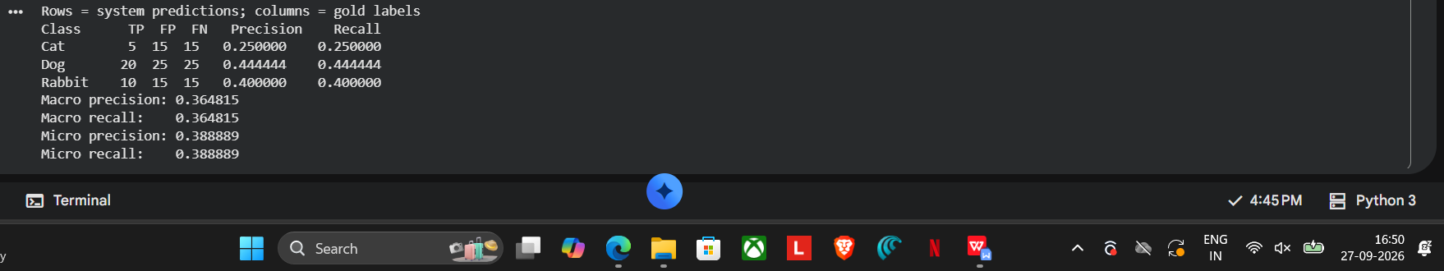
Part II. Programming

Q1. Programming: Bigram Language Model Implementation (based on “Activity: I love NLP corpus” slide)

Tasks:
Write a Python program to:
- Read the training corpus:
- <s> I love NLP </s>
- <s> I love deep learning </s>
- <s> deep learning is fun </s>
- Compute unigram and bigram counts.
- Estimate bigram probabilities using MLE.
- Implement a function that calculates the probability of any given sentence.
- Test your function on both sentences:
  - <s> I love NLP </s>
  - <s> I love deep learning </s>
- Print which sentence the model prefers and why.
from collections import Counter
from fractions import Fraction

CORPUS = [
"<s> I love NLP </s>",
"<s> I love deep learning </s>",
"<s> deep learning is fun </s>",
]

def tokenize(sentence):
"""Split on spaces; add one start and end marker if needed."""
words = sentence.split()
if words and words[0] == "<s>":
words = words[1:]
if words and words[-1] == "</s>":
words = words[:-1]
if "<s>" in words or "</s>" in words:
raise ValueError("Boundary markers must be at sentence ends.")
return ["<s>"] + words + ["</s>"]

def train(corpus):
"""Count tokens and adjacent pairs without crossing sentences."""
unigrams, bigrams, contexts = Counter(), Counter(), Counter()
for sentence in corpus:
tokens = tokenize(sentence)
unigrams.update(tokens)
bigrams.update(zip(tokens, tokens[1:]))
contexts.update(tokens[:-1]) # Only words with a successor.
return unigrams, bigrams, contexts

def bigram_probability(previous, word, bigrams, contexts):
"""MLE: count(previous, word) / count(previous with successor)."""
count = contexts.get(previous, 0)
if count == 0:
return Fraction(0, 1)
return Fraction(bigrams.get((previous, word), 0), count)

def sentence_probability(sentence, bigrams, contexts):
"""Include the end marker; unseen transitions give zero in MLE."""
tokens = tokenize(sentence)
score = Fraction(1, 1) # Exact arithmetic avoids underflow.
for previous, word in zip(tokens, tokens[1:]):
score *= bigram_probability(previous, word, bigrams, contexts)
return score

def main():
unigrams, bigrams, contexts = train(CORPUS)
print("Unigram counts (including boundary markers):")
for word, count in sorted(unigrams.items()):
print(f" {word}: {count}")
print("\nBigram counts and MLE probabilities:")
for (previous, word), count in sorted(bigrams.items()):
p = bigram_probability(previous, word, bigrams, contexts)
print(f" ({previous}, {word}): count={count}, "
f"P={p} ({float(p):.6f})")

tests = CORPUS[:2]
scores = []
for sentence in tests:
tokens = tokenize(sentence)
factors = [bigram_probability(a, b, bigrams, contexts)
for a, b in zip(tokens, tokens[1:])]
score = sentence_probability(sentence, bigrams, contexts)
scores.append(score)
print(f"\nSentence: {sentence}")
print(" Factors: " + " * ".join(map(str, factors)))
print(f" Probability: {score} = {float(score):.6f}")

if scores[0] == scores[1]:
print("\nThe model gives both sentences the same probability.")
else:
best = 0 if scores[0] > scores[1] else 1
print(f"\nPreferred sentence: {tests[best]}")
print("S1 has probability 1/3; S2 has probability 1/6.")
print("P(NLP | love) and P(deep | love) both equal 1/2.")
print("S2 also has P(</s> | learning) = 1/2.")
print("P(</s> | NLP) = 1, so S1 is twice as probable.")

if __name__ == "__main__":
main()

